Project 3 final report notes
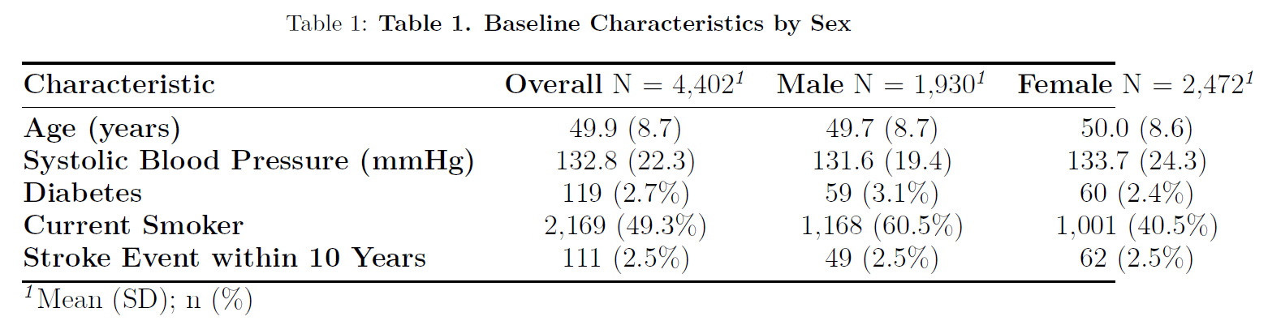MAKE TABLE 1 with DEMOGRAPHICS ETC
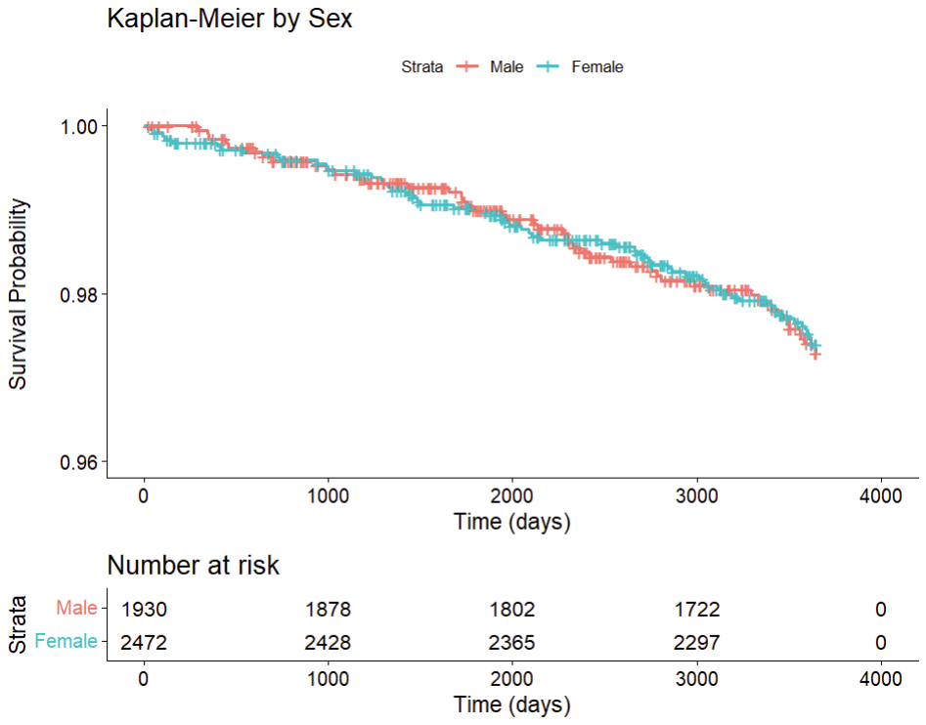

BMI and cholesterol both cross and then bp meds have a clear separation
BP Meds — clear separation → likely worth including
Given this I would lean toward dropping BMI and cholesterol from the model for two reasons:
They were already debated candidates
The crossing curves suggest they may violate the PH assumption which would cause problems in the Cox model
smoking they follow the same curve so I don't think we should include that but good to mention in the report that we checked it
complete case analysis lost 60 due to bp meds not using bmi or hr because won’t work in the model

Male Model:
- Stepwise dropped BPMEDS (AIC improved from 661.41 to 660.50 without it)
- Final model: SYSBP, AGE, DIABETES — all three highly significant
- Concordance = 0.789 → model discriminates well
Female Model:
- Stepwise kept BPMEDS (removing it barely changed AIC: 838.58 vs 838.59, essentially identical)
- SYSBP and AGE are highly significant
- DIABETES and BPMEDS are not significant (p = 0.30 and p = 0.14) but DIABETES is forced in and BPMEDS was retained by stepwise
Important note on BPMEDS in females — since the AIC difference is essentially negligible (0.01), this is a borderline call. Worth mentioning in your report that BPMEDS was retained by stepwise in females but the evidence for its inclusion is weak.

Statistical test results — both models pass:
- All individual variables and global tests have p > 0.05 in both models
- Female model looks particularly clean with very high p-values
- Male DIABETES is borderline (p = 0.056) but still passes the 0.05 threshold

The plots — DIABETES residuals showing a pattern: This is worth noting even though the test says p = 0.056. The fact that the plot shows a non-random pattern for DIABETES in both models suggests there may be some mild violation, even if it doesn't reach statistical significance. This is actually common with binary variables like DIABETES, especially when events are rare.
A few things to consider:
- It's not severe enough to act on statistically — the test p-values hold
- It could be due to small numbers — you only have 48 and 59 events in males and females respectively, which makes residual plots noisy
- Worth mentioning in your report — note that DIABETES showed slight non-randomness in residual plots but the formal Schoenfeld test did not indicate a significant violation
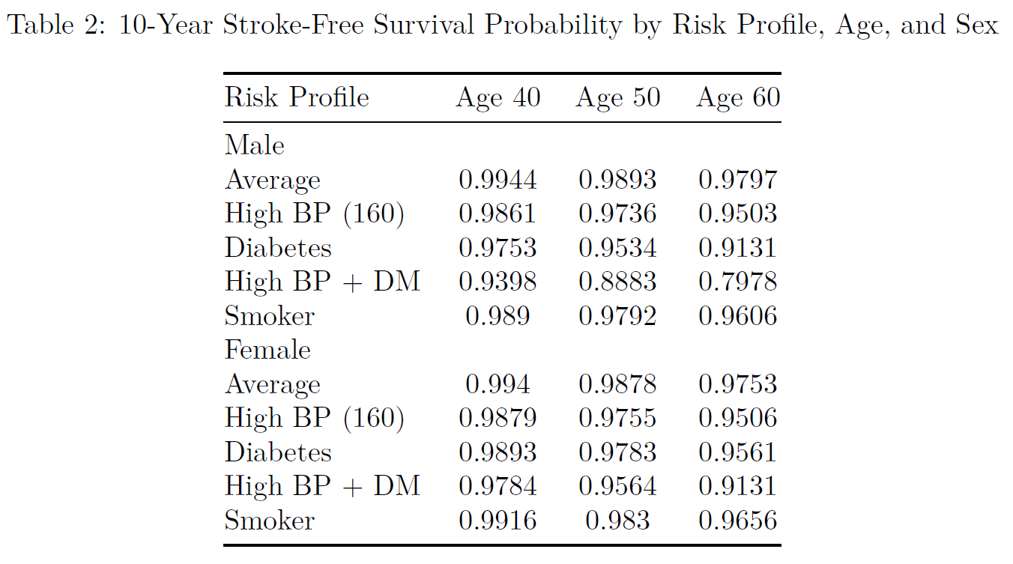
*** add a caption
Change to survival probability instead of probability of death
